Simple Ways to Improve Your Mood – and Your Interiors – During Lockdown
Happy New Year! While the beginning of 2021 is looking a lot like the majority of 2020 for us all, there is certainly a lot more to look forward to this year.
The COVID-19 vaccine rollout brings with it a light at the end of the tunnel – but while we are still in lockdown, we recognise that you may be looking for more ways to lift your mood.
Pandemic or not, happiness begins at home – and there are lots of small changes you can make to improve how you feel by improving your interiors. To start, here’s what we suggest…
Declutter
The charity shops may be shut, and the refuse centres overrun, but that doesn’t mean decluttering should be relegated to the bottom of your to-do list.
If you feel up to it, use any free time in lockdown to declutter your space – even if you just tackle one drawer or cupboard at a time. There are few things more satisfying than having a good clear out, so why not start today?
Get the whole family involved and see how much stuff you can bag up to donate later. You may even find some bits and pieces worth selling – and the extra money could go towards some new accessories for the home, which should also put a smile on your face.
Think About Fragrance
When it comes to fragrance, you probably have a ‘signature scent’ you love spritzing on in the morning. What about your home, though?
You’d be surprised how something as simple as adding a candle, reed diffuser or oil burner to your space can brighten your mood. While guests aren’t popping round unannounced at the moment, that doesn’t mean you shouldn’t treat your home – and yourself – to a new candle.
Look for candles that feature calming, essential oils like lavender, if you want a scent that fills the house and leaves you feeling relaxed too. Or choose a different scent for each room, adding flowery fragrances in the bathroom, homely aromas in the kitchen (think ‘baking smells’ like apple and cinnamon, or vanilla) and calming scents in the bedroom.
Create a Relaxing, Reading Nook
Is the daily grind is dampening your spirits? Feeling fed up with your space? A few small and simple changes can make all the difference.
If you can, allocate some time to transform just a corner of your room. Whether that means rearranging your furniture or adding some new prints to the wall, giving your space a new lease of life might do you – and your home – the world of good.
Why not create a cosy reading book in your dining room, for instance? Add a comfy chair, some calming plants and a candle or two and curl up with a good book – if you have time, that is.
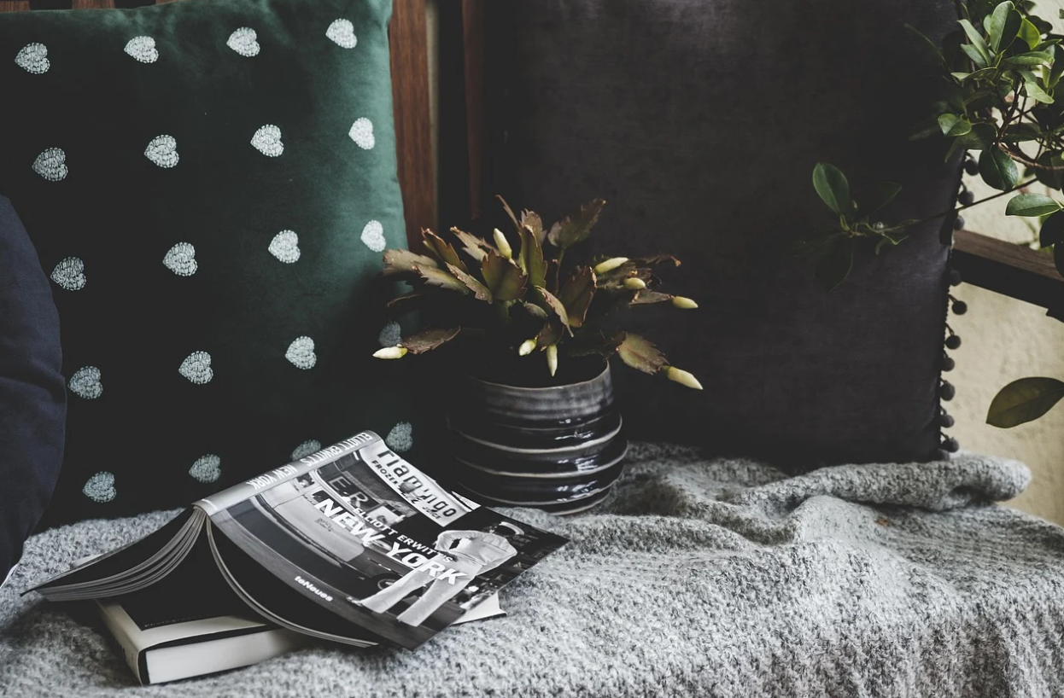
Rethink Your Space
Is your space reflective of your lifestyle? What we mean by that is does it work with you or against you? If, for example, you spend a lot of time in the kitchen, is it orderly enough that you enjoy being in there?
Or perhaps your bedroom could benefit from being a little less cluttered as well, to encourage a better night’s sleep. Rethink your space – and how it works for you – and give it a fresh new lease of life in whatever way you deem necessary.
That might mean adding some new, plusher cushions to your sofa, reorganising your kitchen so everything you need is in easier reach, or ensuring you keep paperwork away from the bedroom.
Rethink your space and we bet you’ll lift your mood in the process.
Want more inspiration for the home? Stay tuned here on the Hello Sunday site.

